Investigating Graphs – Part A
In previous work you learnt that the graph of $y=a{(x-b)}^{2}+c$ has the same shape as that of $y=ax^{2}$ but has been translated horizontally b units and translated vertically c units. The effect of the dilation factor, a, is to stretch or compress the curve depending on the value of a. Furthermore, if a was negative, the graph was inverted.
The aim of this investigation is to investigate translations and dilations in other functions.

[2 marks]
On the axes below, accurately graph the following function: $y=f\left(x\right)=\frac{1}{x}$.
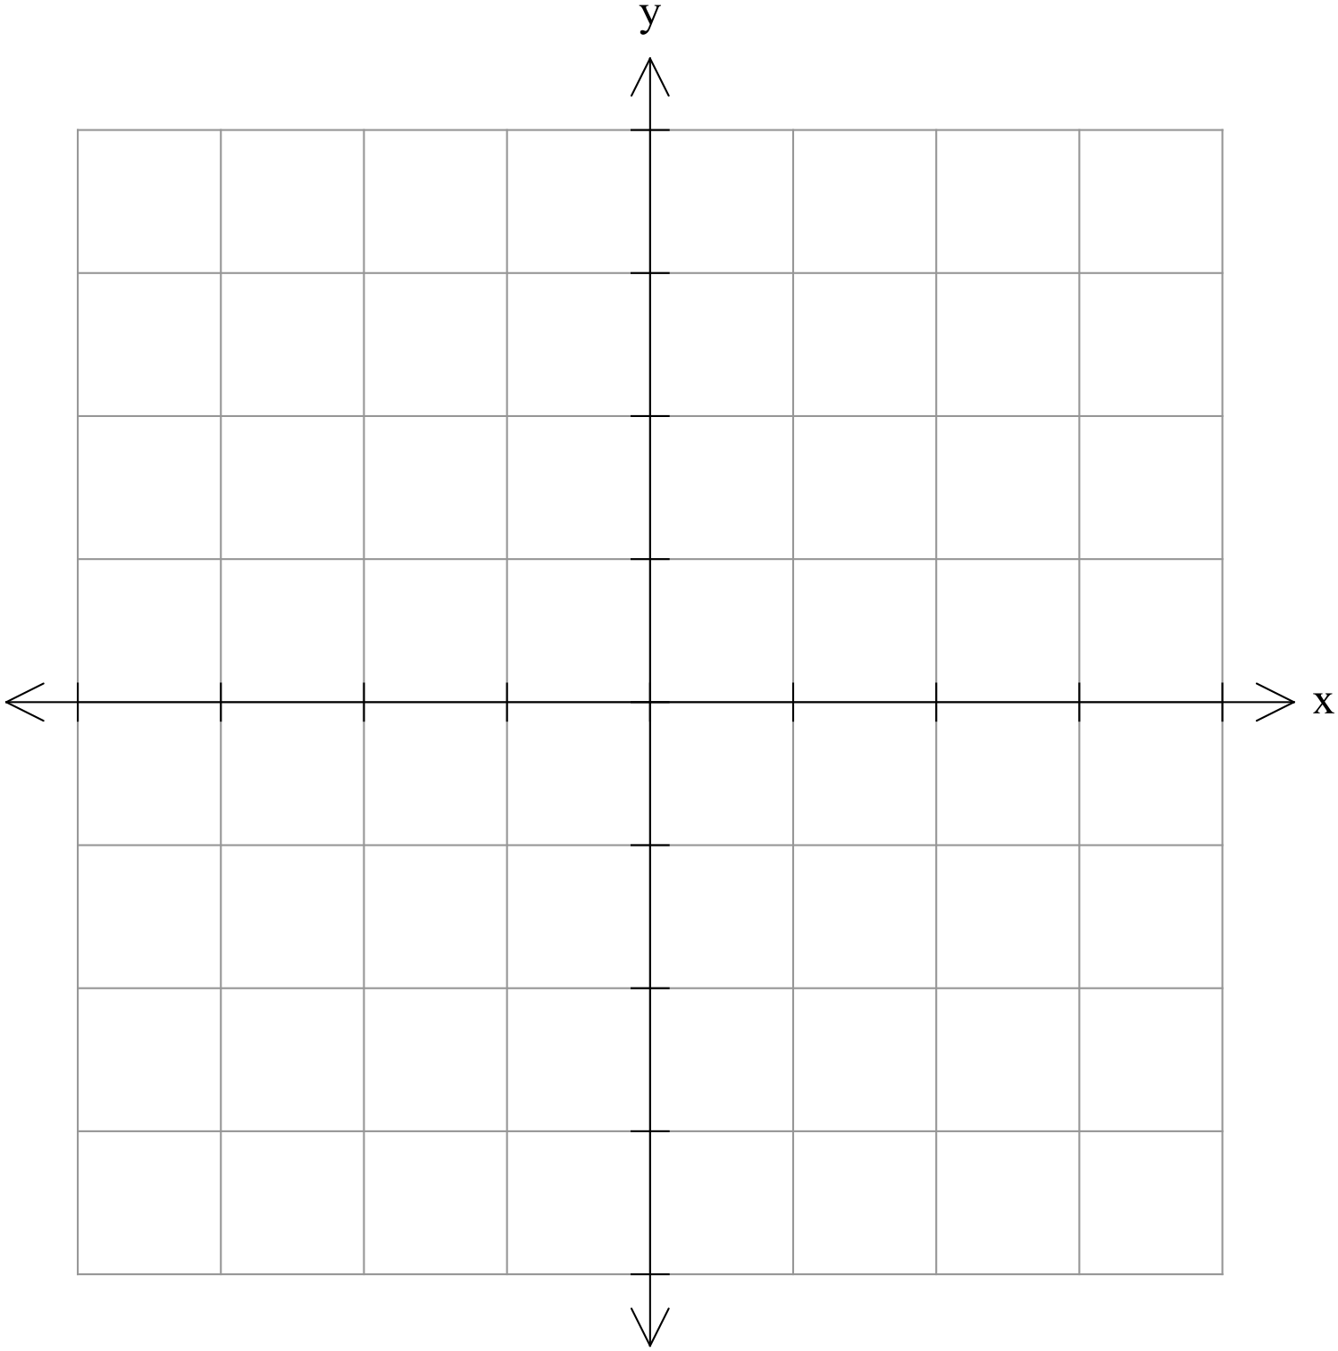


[5 marks]
On the following axes, labelling everything clearly, graph the following functions:
$y=\frac{1}{x}$
$y=\frac{2}{x}$
and $y=\frac{4}{x}$



[4 marks]
On the following axes, labelling everything clearly, graph the following functions:
$y=\frac{-1}{x}$
and $y=\frac{-2}{x}$

[3 marks]
Comment on the effects that changes in a have on the graphs of $y=\frac{a}{x}$ $(y=af\left(x\right))$.

[5 marks]

On the following axes, labelling everything clearly, graph the following functions:
$y=\frac{1}{x}$
$y=\frac{1}{x}+1$
and $y=\frac{1}{x}-2$



[5 marks]
On the following axes, labelling everything clearly, graph the following functions:
$y=\frac{1}{x}$
$y=\frac{1}{x+1}$
and $y=\frac{1}{x-2}$

[4 marks]
Comment on the effects that changes in b and c have on the graphs of$y=\frac{1}{x-b}+c$ $(y=f\left(x-b\right)+c)$.


[3 marks]
On the following axes, labelling everything clearly, graph the following function:
$y=\frac{1}{x-1}+2$

[4 marks]
(a) If the graph of $y=\frac{e}{x+1}+4$ has a y-intercept of 7, determine the value of e.

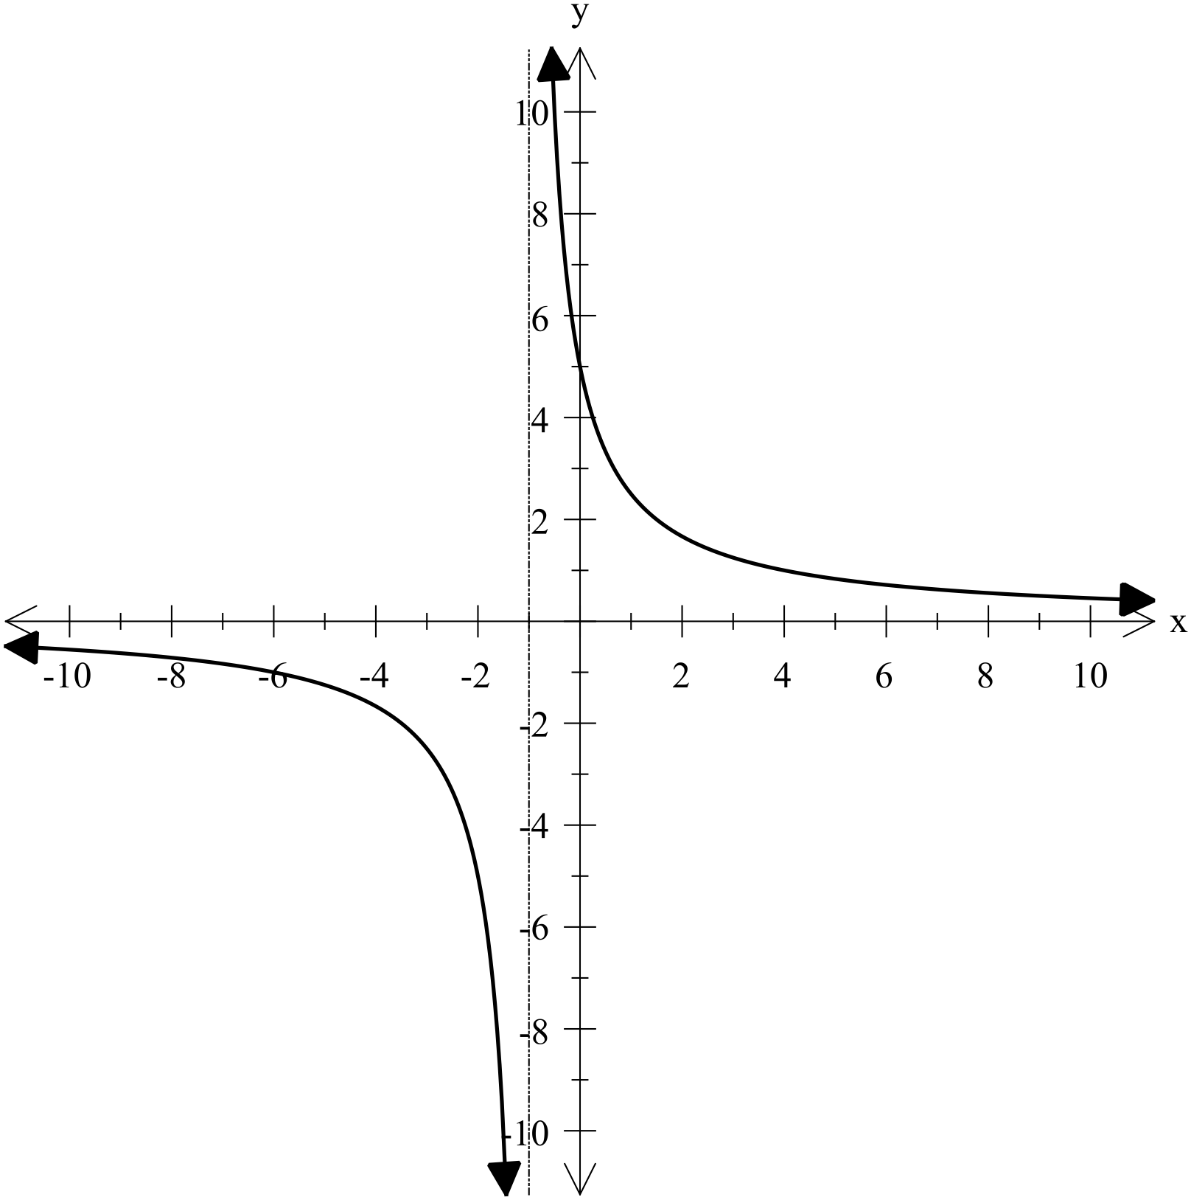
(b) The graph shown has an equation given as
Determine the values of r and s.

Investigating Graphs – Part A

[2 marks]
On the axes below, accurately graph the following function: $y=f\left(x\right)=\frac{1}{x}$.

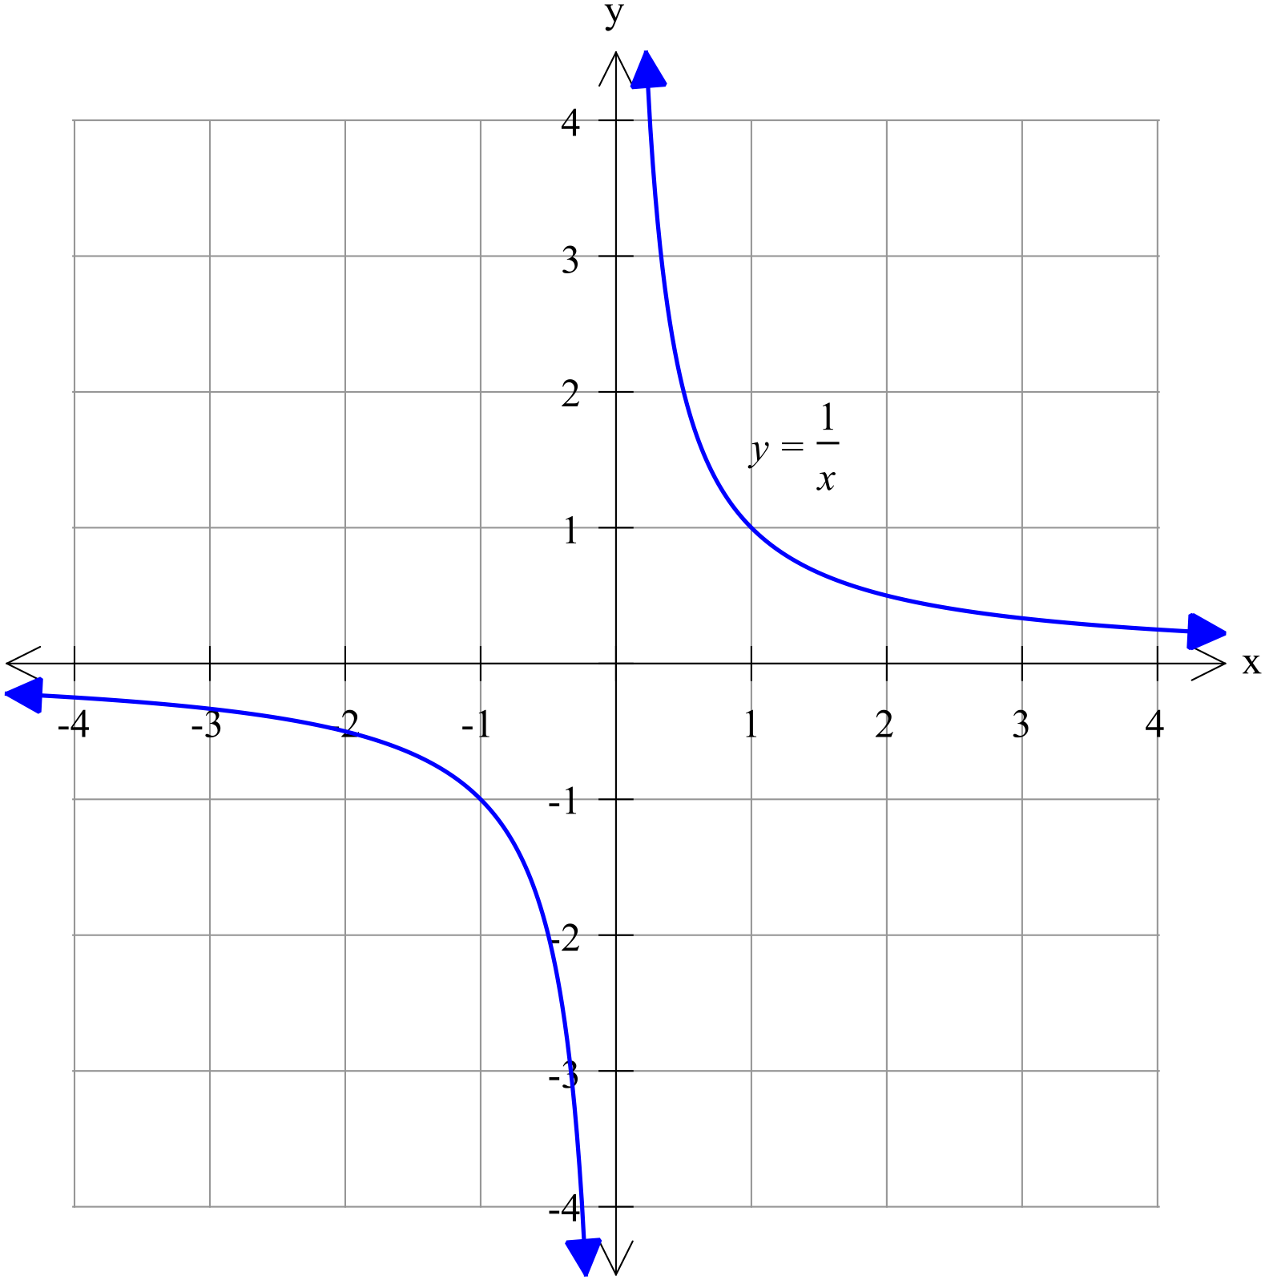

[5 marks]
On the following axes, labelling everything clearly, graph the following functions:
$y=\frac{1}{x}$
$y=\frac{2}{x}$
and $y=\frac{4}{x}$

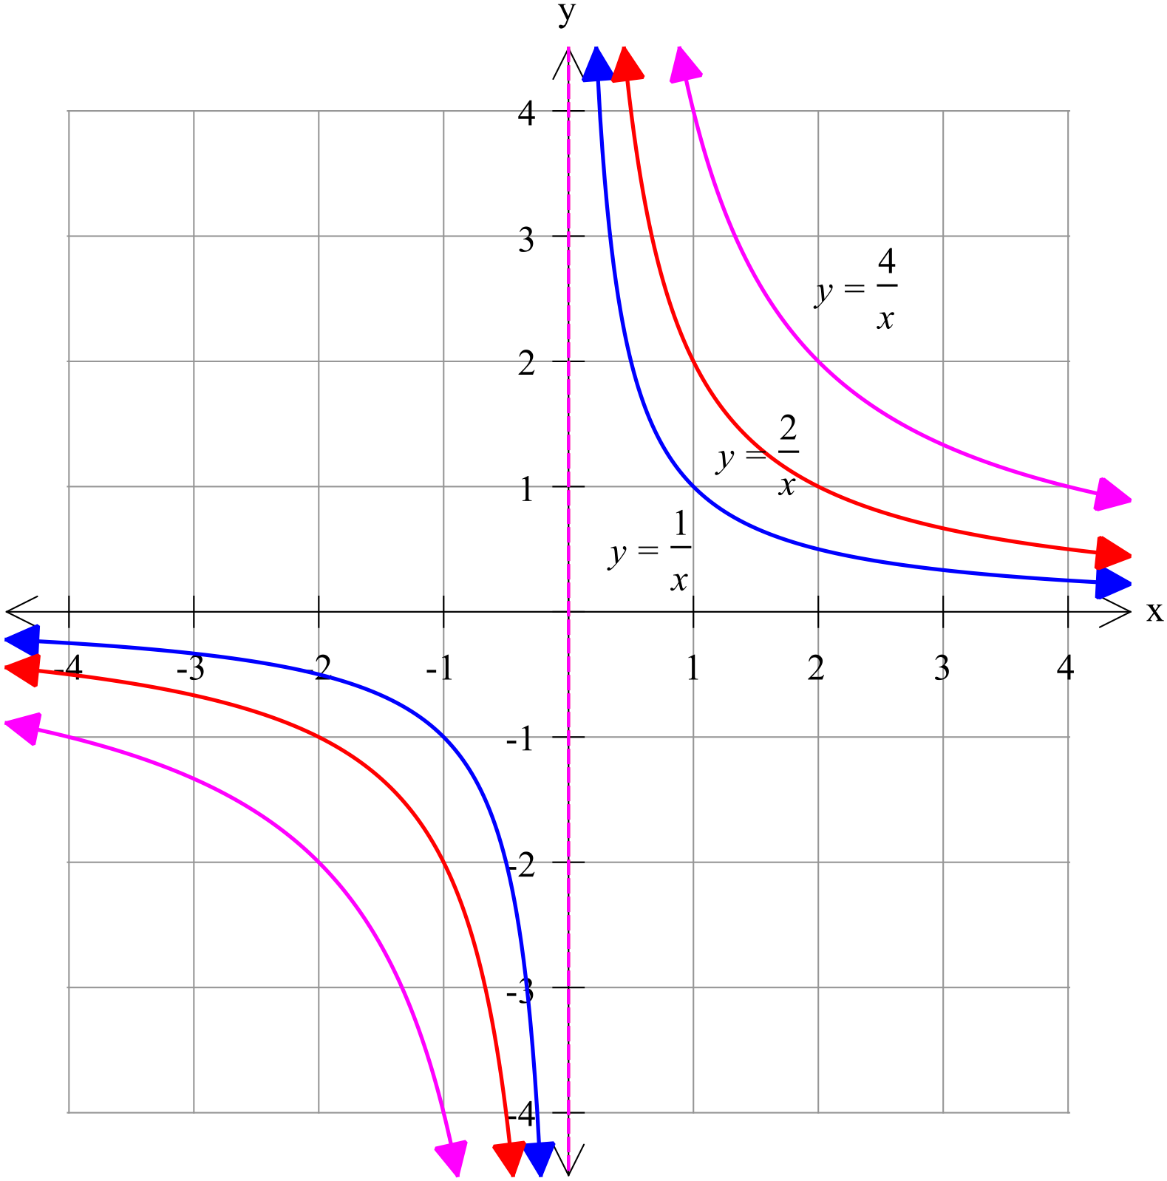

[4 marks]
On the following axes, labelling everything clearly, graph the following functions:
$y=\frac{-1}{x}$
and $y=\frac{-2}{x}$

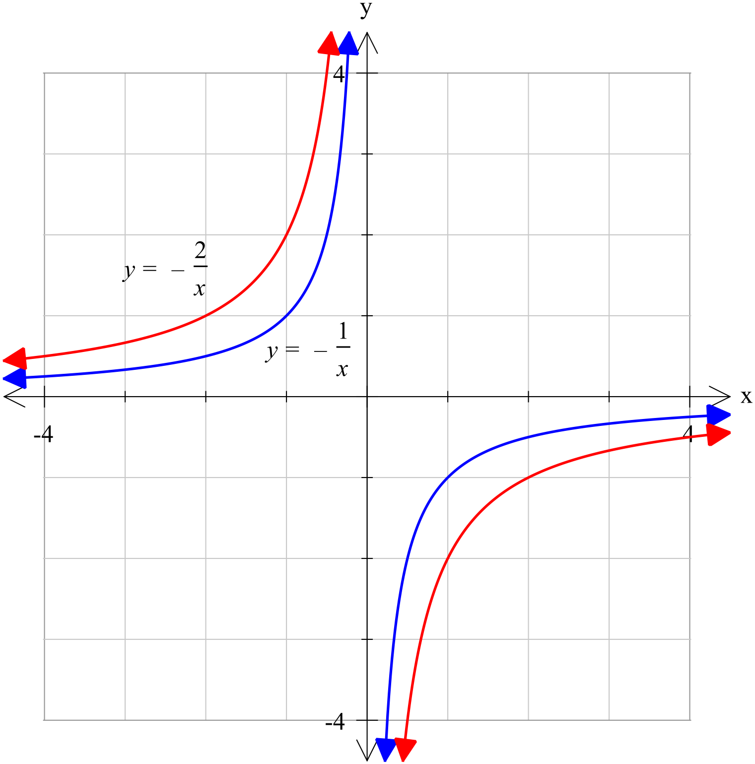

[3 marks]

Comment on the effects that changes in a have on the graphs of $y=\frac{a}{x}$ $(y=af\left(x\right))$.

a is a dilation factor which stretches or compresses the graph of $y=\frac{1}{x}$ depending on the value of a. This affects the gradient of the curve and thus the distance the curve is from the axes. The larger the value of ⏐a⏐, the further it is from each axis.
Furthermore, if a is negative, the graph is inverted. That is the curves are in the second and fourth quadrants, rather than in the first and third.

[5 marks]
On the following axes, labelling everything clearly, graph the following functions:
$y=\frac{1}{x}$
$y=\frac{1}{x}+1$
and $y=\frac{1}{x}-2$

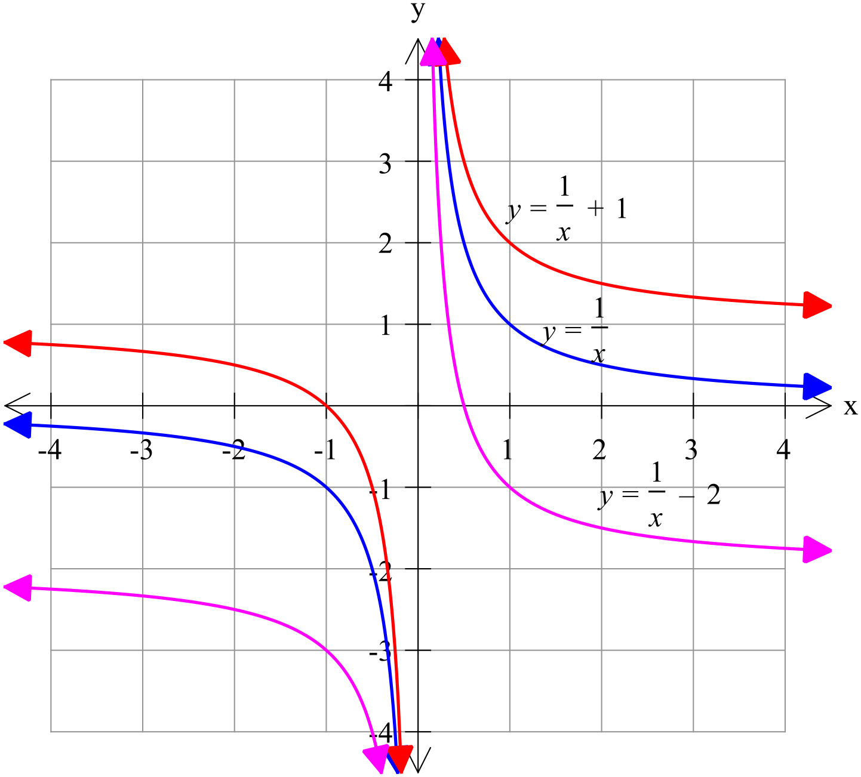

[5 marks]
On the following axes, labelling everything clearly, graph the following functions:
$y=\frac{1}{x}$
$y=\frac{1}{x+1}$
and $y=\frac{1}{x-2}$

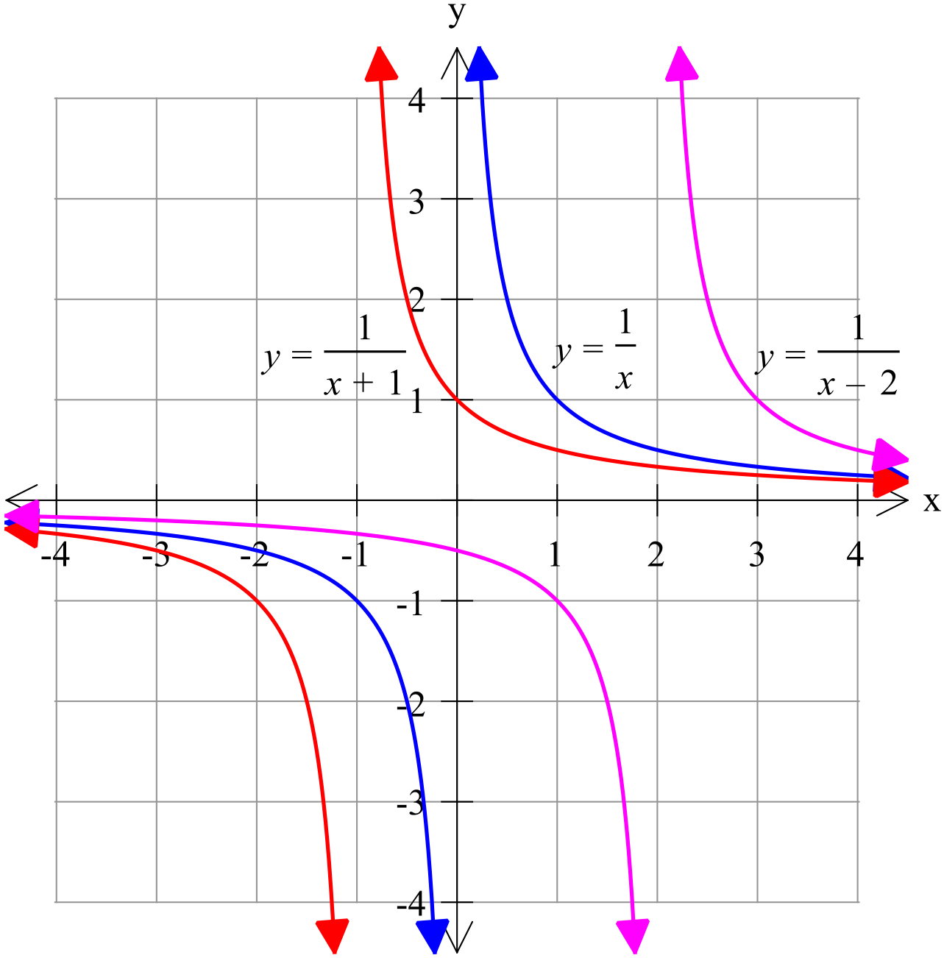

[4 marks]
Comment on the effects that changes in b and c have on the graphs of$y=\frac{1}{x-b}+c$ $(y=f\left(x-b\right)+c)$.

$y=\frac{1}{x-b}+c$ is congruent to $y=\frac{1}{x}$ but has been moved b units right and c units up.
That is b is the distance of the horizontal translation and c the vertical translation.

[3 marks]

On the following axes, labelling everything clearly, graph the following function:
$y=\frac{1}{x-1}+2$

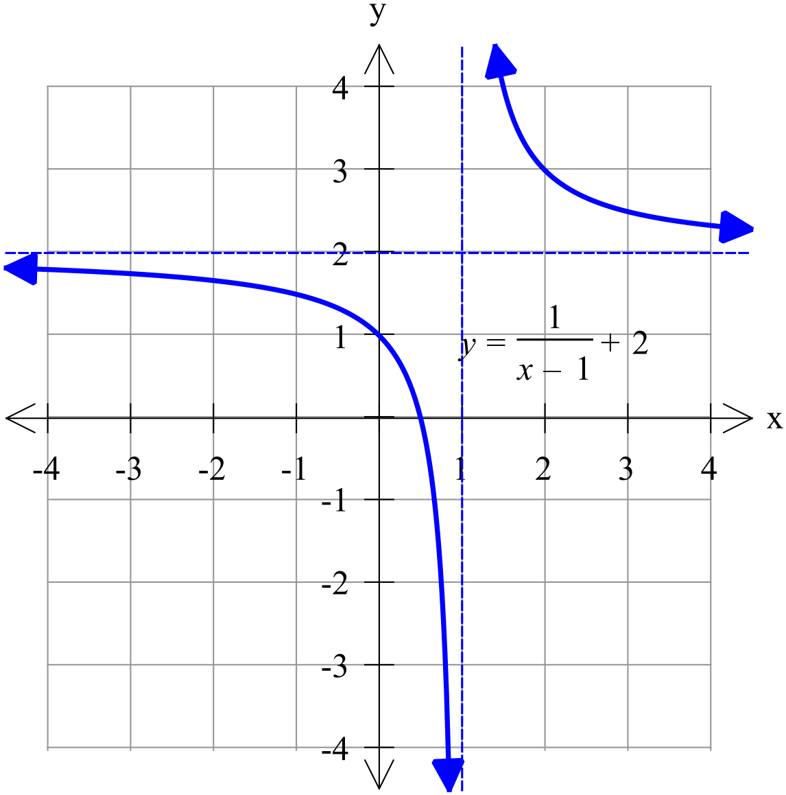

[4 marks]
(a) If the graph of $y=\frac{e}{x+1}+4$ has a y-intercept of 7, determine the value of e.

(a)
$$y=\frac{e}{x+1}+4$$

$$7=\frac{e}{1}+4$$

$$e=3$$

(b) The graph shown has an equation given as
Determine the values of r and s.
$$y=\frac{5}{x+1}$$

$r=5$ and $s=-1$

Total: 35 marks

